
SOP Title: | Ecommerce Creating Returns Backlog & Detail Reports
Document Storage Location: | STACS/Management/SOPs – Logistics and Warehousing | Document #: | SEASOP388v100
SOP Originator: | Torino Thomas | Last Edited by: | Torino Thomas
Effective Date: | Nov 13, 2020 | Last Edited Date: | Nov 13, 2020
Other:

- Purpose
  - The purpose of this SOP is to provide a Work aid for any Samsung Ecommerce Logistics Personnel in the area of returns.
- Scope
  - Coppell eComm: Daily Returns operations
- Responsibilities
  - SEA: To ensure the timely processing of eComm Returns and to resolve issues that may arise during the processing of those Returns.
- Instructions
    - Creating Returns Backlog & Detail Reports
    - Geodis Returns Backlog Report: Each morning a member of the Operations team (New Jersey) will compile a report which lists the aged returns
      - The report will have 3 Tabs: RECAP, Total Delivery Backlog, and Total In Transit
      - Recap- Provides a high level overview of returns delivered not processed and returns in transit (see figures 1&2)
(fig1.) ( Fig2.)
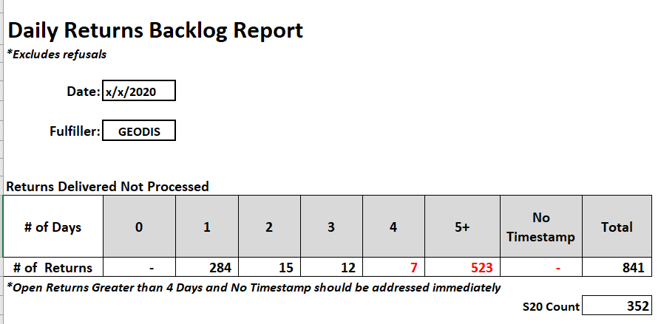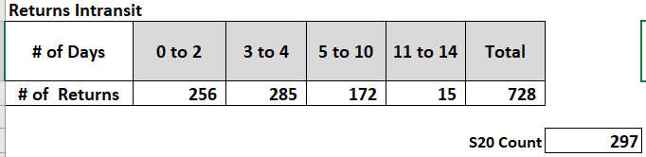
            - Returns delivered not proessed chart( fig1.) provides a view of the aged returns from newest to oldest.
            - The focus should be on the 5 plus days while ensuring the 2 to 3 days don’t become 5 plus days.

      - Returns in Transit
          - Provides a snapshot of the returns that are in transit back to Samsung. This snap shot also shows them by age. The total intransit tab provides days in transit, PO ID, SKU, tracking # and Shipment T’s (Fig 2.)
      - Total Delivery Backlog
          - The total delivery backlog is where all the openreturns are listed.
          - We will Categorize these Returns, and then add notes after research has been done to establish the status.
(Fig 3)
          - Start by sorting the sheet oldest to newest using the backlog days column.
          - Next sort the backlog days column by days. Start with 1 day go the Category column and label them all one day.(see Fig 4)
(Fig 4)
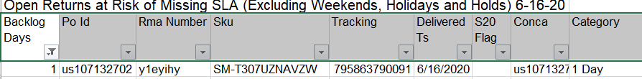

          - Continue with 2,3,4 days.
          - Anything 5+days would have been labeled on the previous day’s Return Daily Update report. (ideally there should be no more than 5 plus days aged).
          - Once all entries on the sheet have been categorized, reference and import the exceptions report, the Triage report, Unsent report, and the Fraud report to ensure that the data is consistent.
          - Insert a Pivot table based on the Open Daily Returns report tab.
            - The pivot will have the Category & Total.
            - When creating the pivot table use the Description in the Rows and Values column.
            - Asign a Status, Responsible party, & Completion Target to each line.
              - Status and Responsible party will come from prior reports
(Fig5)
      - Send to distribution lists below:
          - Geodis
            - SEPEDA, Elba <Elba.SEPEDA@geodis.com>;
            - MORGAN, Verline <Verline.MORGAN@geodis.com>;
            - Turner, Eric <eric.Turner@Geodis.com>;
            - Michael BELDOWSKI <Michael.BELDOWSKI@geodis.com>;
            - TURNER, Gary <Gary.TURNER@geodis.com>;
          - SEA Logistics eComm
            - eComm Team <eCommTeam@sea.samsung.com>;
            - Joseph Morrow <j2.morrow@sea.samsung.com>;
            - Kevin Leverett <kleveret@sea.samsung.com>;
            - Michael Schweninger <michael.s3@sea.samsung.com>;
            - Parag K Gupta <parag.gupta@sea.samsung.com>;
            - Simone DeSouza <s.desouza@sea.samsung.com>
            - Zainab Kalla <z.kalla@partner.sea.samsung.com>;
          - SEA Other
            - Romano Kabir <r.kabir@sea.samsung.com>;
            - Sabarish Sreemulanathan <s.sreemulana@sea.samsung.com>;
            - James McLaughlin <james.mc@sea.samsung.com>;
    - Returns Details Report
      - Log into Visibility
        - Click on  (Control tower)
        - From the drop down choose Synpase Reports
        - Schedule Report
        - From the list choose Samsung Returns Details Report
        - Enter the start date (prior day 12:00 AM)
        - Enter the end date (prior day 12:00 PM)
        - Click on 
        - You will receive a notification in the top Right 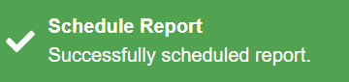 (an email notification that your report has been generated is also sent)
        - At the top of the page under View Scheduled Reports will be listed the report generated
        - Click to open the report
      - Once the report opens sort the Receipt Date by Oldest.
      - Sort and filter the Arrival Date column
        - Select only Returns with no Arrival Date
            - Copy all these to a new excel document
            - Send to distribution lists below:
              - Geodis
                - SEPEDA, Elba <Elba.SEPEDA@geodis.com>;
                - MORGAN, Verline <Verline.MORGAN@geodis.com>;
                - Turner, Eric <eric.Turner@Geodis.com>;
                - Michael BELDOWSKI <Michael.BELDOWSKI@geodis.com>;
                - TURNER, Gary <Gary.TURNER@geodis.com>;
              - SEA Logistics eComm
                - eComm Team <eCommTeam@sea.samsung.com>;
                - Joseph Morrow <j2.morrow@sea.samsung.com>;
                - Kevin Leverett <kleveret@sea.samsung.com>;
                - Michael Schweninger <michael.s3@sea.samsung.com>;
                - Parag K Gupta <parag.gupta@sea.samsung.com>;
                - Simone DeSouza <s.desouza@sea.samsung.com>;
                - Zainab Kalla <z.kalla@partner.sea.samsung.com>;
              - SEA Other
                - Romano Kabir <r.kabir@sea.samsung.com>;
                - Sabarish Sreemulanathan <s.sreemulana@sea.samsung.com>;
                - James McLaughlin <james.mc@sea.samsung.com>;
      - Look at the quantities and units columns to ensure there are no overages (only 1-s are showing)
        - If there are no overages (numbers greater than 1) in the column there is nothing more to do
        - If there are overages, copy the overages to a new excel
        - Send file to distribution lists listed in 3.a.2
      - Ensure that the correct condition codes are used. (only Acc, DAM, & UNS should appear)
        - If any other disposition codes are used Copy all these to a new excel document.
        - Send file to distribution lists listed in 3.a.2
      - Identifying RMAs and Refusals
        - To detrmine if a return is an RMA or Refusal we will use the Reference column and the PO column.
            - Scroll over to an empty column of the right side of the sheet and label it (Refusal/ Rma)
            - Use if/then formula to quickly identify the RMAs from the Refusals (=IF(A3=B3,"refusal","Rma")
              - If the Reference # and the PO match then it is a refusal
              - If the Reference # and the PO do not match then it is a RMA
      - Determine the age of a return
        - Scroll over to an empty column on the right side of the sheet & label it Time. (See fig 6)
        - Use formula that will yield the time difference
            - = Receipt date- Arrival (=G3-F3)
            - Format the column so it is a number
(Fig 6)
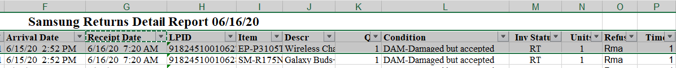
      - Insert a Pivot table based on the Open returns Report
          - When creating the pivot table use the Descrition in the Rows and Values fields.
          - The pivot will yield a list of all items on the details report along with the totals of each item.(see Fig 7)
(Fig 7)
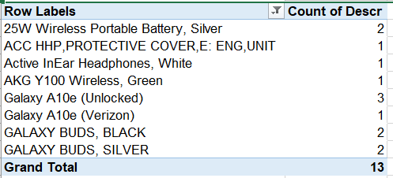
    - Weekly Returns Detail Report: generate a weekly version of above report which covers Sunday through Saturday
        - Create KPI table via the below steps
        - Open up excel document
          - Go to PO column
            - Remove duplicates
          - Remove any items which did not have Arrival Date
          - Sort by receipt date, oldest to newest
          - Insert 2 columns between Receipt Date and LPID
            - First inserted column KPI/Not KPI
            - Second inserted column is labelled Days
              - =Receipt Date – Arrival Date
              - Format column to numbers
              - Filter column for 0 to 1 day
                - In KPI/Not KPI column label the filtered items as KPI
              - Filter columns for Days > 1 day (2 or more)
                - In KPI/Not KPI column label the filered items as Not KPI
        - Create Pivot
          - Based on KPI/Not KPI column
            - Add KPI/Not KPI column to Rows
            - Add Qty column to Values field
              - Make sure it is set to Sum of Qty
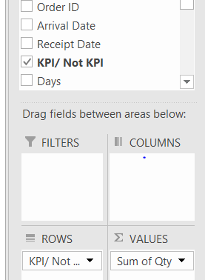
          - The pivot table will look like below:
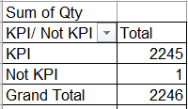
          - Add KPI percentage at the bottom so table looks like below
            - KPI=KPI Total/Grand Total
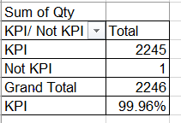
          - If there is anything in the Not KPI row create a Pareto table for those items
            - Pareto table from the Not KPI information
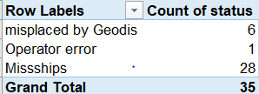
            - Create a chart based on the Pareto table
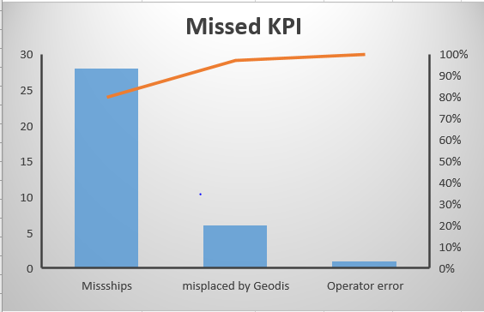
            - Send information to:
              - Parag K Gupta <parag.gupta@sea.samsung.com>;
              - Viraj Baraskar: v.baraskar@partner.sea.samsung.com

